Maybe change the name of this file? - No, it's perfect

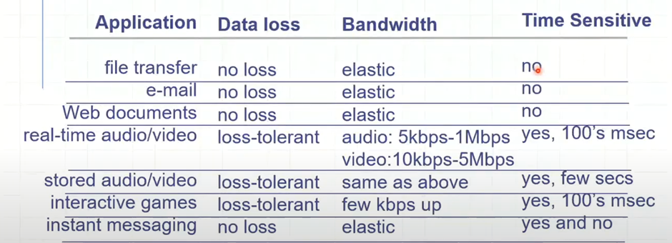

### TCP

- **connection-oriented**: setup required

- ***reliable transport**:* between sending and receiving process

- ***flow control**:* sender won’t overwhelm receiver

- ***congestion control**:* throttle sender when network overloaded

- ***does not provide**:* timing, minimum bandwidth guarantees

- uses:

- server: bind; listen; accept

- client: connect

- client + server: close; shutdown

### UDP

- unreliable data transfer between sending and receiving process

- does not provide: connection setup, reliability, flow control, congestion control, timing, or bandwidth guarantee

- advantaged:

- less latency;

- higher bandwidth;

- broadcast (one sender - multiple receivers)

- uses:

- server: bind (no listen/accept)

- client: connect

- client + server: close;

- checksum

TCP vs UDP:

Write: TCP sends stream of bytes - UDP sends packets of bytes

Read: TCP reads from the stream - UDP reads bytes from one packet (1 read = 1 packet max 64kb) (bytes not read from stream in tcp stay available for next read - not read bytes from a packet in udp are lost!)

Flow: TCP flow: neither party can overflow the other - UDP flow: you can send as much data but the receiver will start losing packets

Use straight through Ethernet cable for the following cabling:

* Switch to router
* Switch to PC or server
* Hub to PC or server

Use crossover cables for the following cabling:

* Switch to switch
* Switch to hub
* Hub to hub
* Router to router
* Router Ethernet port to PC NIC
* PC to PC

Broadcast:

* LAN
* Only over UDP
* Special destination address (Universal broadcast or LAN broadcast = largest IP address from that network)

IP Addresses:

* 32-bit identifier for host, router interface
* Private IP cant be routed
* Interface = connection between host/router and physical link
* Network:
  + Device interfaces with same network part of IP address
  + Can physically reach each other without intervening router = no crossroads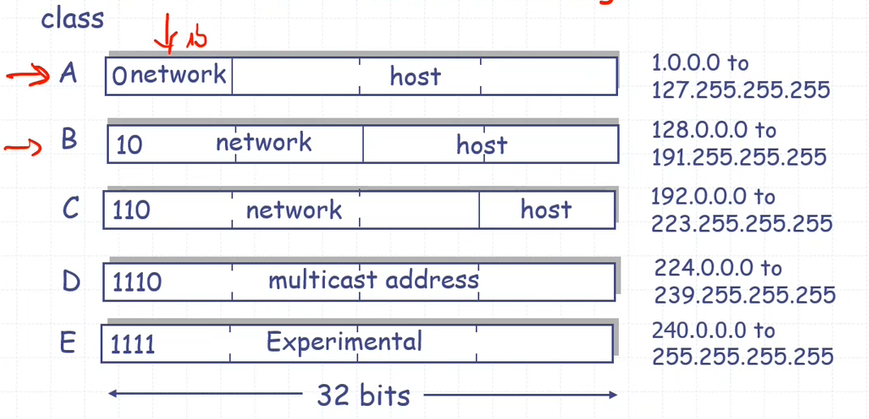

Class-full addressing:

CIDR: Classless InterDomain Routing (next addressing schema)

PRIVATE IP ADDRESSES

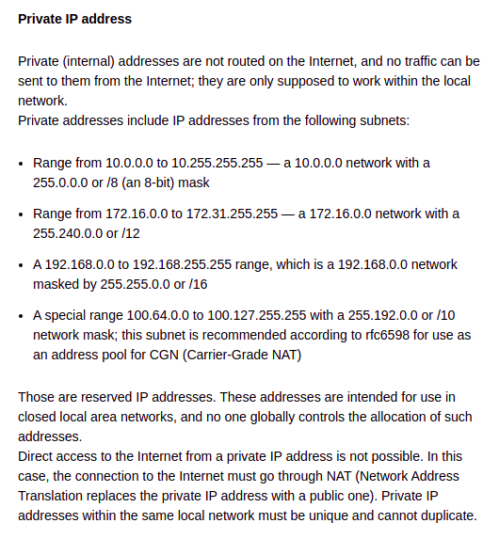

RELAY AGENT - host or router that sends DHCP packets between clients and servers (it can serve DHCP server on another network to configure the IP addresses of computers inside its network)

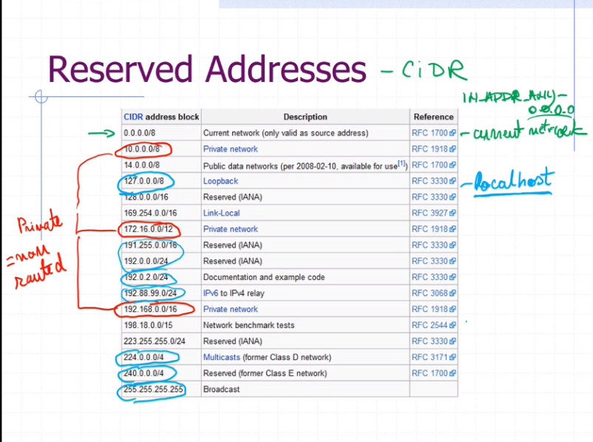

Divide into subnets:

1. Take the network with the biggest number of hosts x
2. Find the biggest number 2^y bigger than x + 1 router + 1 network address + 1 universal broadcast
3. Do the same from biggest to lowest number of hosts
4. Check if total number of power of 2 hosts fit in the subnet mask
5. Split IPs based on the number power of 2 for every subnet

ARP and MAC:

* ipv6 doesn't handle fragmentation
* MAC address - Data link layer
* Data link broadcast MAC address: FF:FF:FF:FF:FF:FF